Chapter 5 Legs

“Every individual is the architect of their own fortune.”

Claudius
10 BC-AD 54
Roman Emperor

With the preceding six heavy Stones strategically sited, construction begins for rotational fundamentals. The order of chapters in Part II Turn and Torque coincides with the transfer of energy up the kinetic chain. Structuring chapters in this way provides:

- Useful concepts and enhanced understanding as related to the generation of bat speed.

- An efficient, systematic, and step-by-step “roadmap” to maximize bat speed development.

Ground Power

Here is a quick recap of Part I Hitting Position regarding the development of “ground power.” The legs and feet working against the ground originate the chain of energy:

- Ground Power during Gather.

The hitter gathers their weight rearward as the first move out of their stance. The rearward motion of the torso generates energy in the form of muscle tension. The inner part of the rearfoot and big toe dig into the ground, anchoring the swing and establishing a point to drive forward.

- Ground Power during Approach.
The front foot lifts (strides) as the flexed rear leg pushes against the ground initiating the approach. The push from the flexed back leg drives the torso forward toward the pitcher. The front foot toe touches as the hitter arrives in hitting position.
From this foundational hitting position developed in Part I Hitting Position, the Pillars in Chapter 5 Legs examine how the legs and feet continue to work against the ground, igniting energy transformation up the kinetic links (see Stone XXI: Kinetic Links).

A hitter’s legs are essential for a powerful swing.

Pillar I
Front Heel Drive

Universal

The Foundations formed in Part I Hitting Position support the construction of Pillars.

The completion of stride precedes front heel drive. Upon stride completion (toe touch), only the front foot's ball or toe is on the ground. The front heel is in the air, and the front leg remains slightly flexed. The front knee, hip, and shoulder are closer to the plate than the rear knee, hip, and shoulder (front side in), creating a powerful cocking of hips (images below).

These Foundations put the hitter in a dominant position, ready to drive the front heel to the ground to help start the rotation of hips.

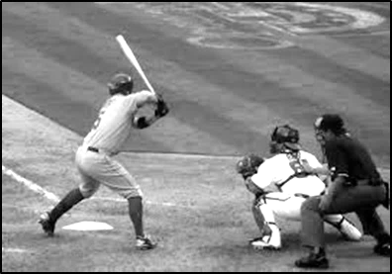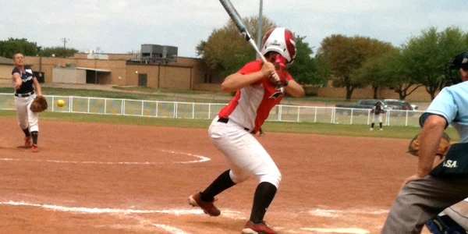
Hitting Position (Baseball and Fastpitch Softball)

Front Heel Drive Mechanics

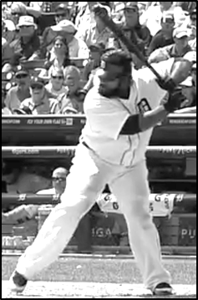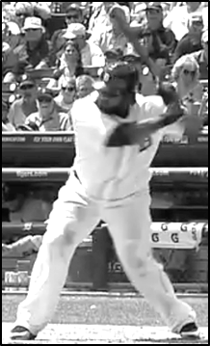

Both heels are on the ground for a few milliseconds; weight is evenly distributed.
Front heel drive consists of “planting” the raised front foot heel on the ground. Most High-Level hitters evenly distribute weight between feet at this point in the swing. Core rotation (see Pillar VII: Core Rotation) then initiates from this balanced position.

Some hitters pivot on the ball of the front foot simultaneously with the front heel planting. They pivot to a slightly more open angle at contact (see Pillar II: Front Foot Angle at Contact).

Front Heel Drive Benefits

Front heel drive is a Universal hitting fundamental enhancing:

- Hip and shoulder separation.

Having the front heel raised at toe touch allows front heel drive to create a pulling action on the lead hip. This pulling action turns the hips while the shoulders remain in a stable position (see Pillar X: Hip and Shoulder Separation).

- Timing.

Front heel drive is a key timing device (see Dome V: Timing of Front Heel Drive). Driving the raised front heel to the ground initiates core rotation for most hitters - it is difficult to hold the swing back after planting the front heel.

Front heel in the air allows hitters to hesitate, for a few milliseconds, the start of core rotation for off-speed pitches. Hesitation before executing front heel drive provides a method for many hitters to slightly pause the swing to let the ball travel.

Drills

The Ultimate Hitting Training Guide:

- Tool XIV: Universal Leg Drills, Drill I – Front Heel Drive Drill.

Pillar II
Front Foot Angle at Contact

Universal
Fit to Player
Front foot angle adjustments are small and incremental yet can be surprisingly effective. Front foot angle directs the entire front side's position, affecting timing and degree of core rotation. For a zero-degree angle, point the front foot at the plate. For ninety-degrees, aim the foot at the pitcher.

Universally the front foot angle at contact is between twenty and forty-five degrees.

Three Front Foot Angle Strategies

Here are three prevalent strategies for front foot angles at toe touch and then at contact:

- Most successful hitters land their stride foot, at toe touch, in a closed position (thirty degrees or less). As front heel drive executes and contact occurs, they maintain the front foot in a closed position.

- Some productive hitters are closed at toe touch and then pivot open (not to exceed forty-five degrees) during front heel drive.

- Some power hitters, utilizing an early open, land toe touch at a forty-five-degree angle. This forty-five-degree front foot angle is kept stable during heel drive and through contact. A front foot angle of more than forty-five-degrees encourages “spinning off” the outside pitch, especially with developing hitters.

Closed Front Foot Angle at Contact

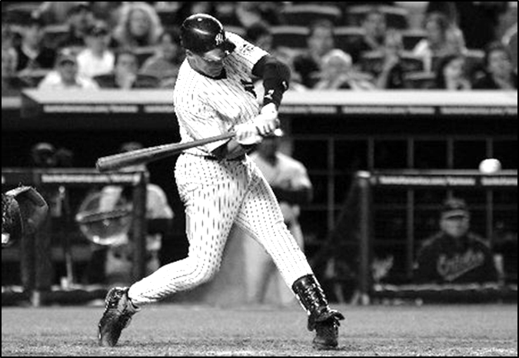
A hitter who spins off the outside pitch is in and out of the path of the ball very quickly. Front foot angle in a more closed position at contact (thirty degrees or less) allows hitters to “stay on” the outside fastball or off-speed. Moreover, with a closed front foot, batters can direct the swing's energy more toward the middle of the field rather than to the pull side.

Front Foot Closed at Contact

If the hitter completely closes off, with the front foot pointed at the plate, then full core rotation is constrained. And, an overly closed position can create difficulties getting the barrel out front on inside pitches. Furthermore, a too closed front foot fosters front knee wear and tear.

Open Front Foot Angle at Contact

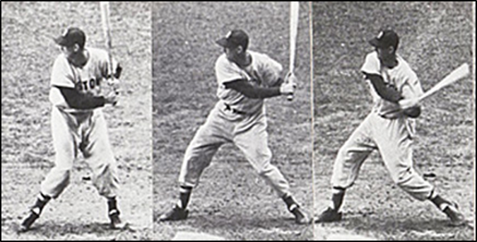
Front Foot Open at Contact

Front foot angle, in a more open position at contact, up to forty-five degrees, may help hitters:

- “Turn on” and “barrel up” the inside pitch.

- Maximize hip and shoulder separation; bio-mechanically, the front foot has to open.

- Maximize bat speed; a power-producing, muscle stretching move, is to open the front foot during front heel drive while counter-rotating the upper body (see Pillar XIV: Rear Shoulder Row).

Developing Hitters

The front foot's excessive opening is a common flaw seen in developing hitters. A too open front foot (pointing at pitcher) typically couples with stepping away from the plate, creating severe plate coverage issues. This shortcoming also directs rotational energy away from the contact point too early (spinning), breaking the kinetic chain's sequencing. Bat speed falls.

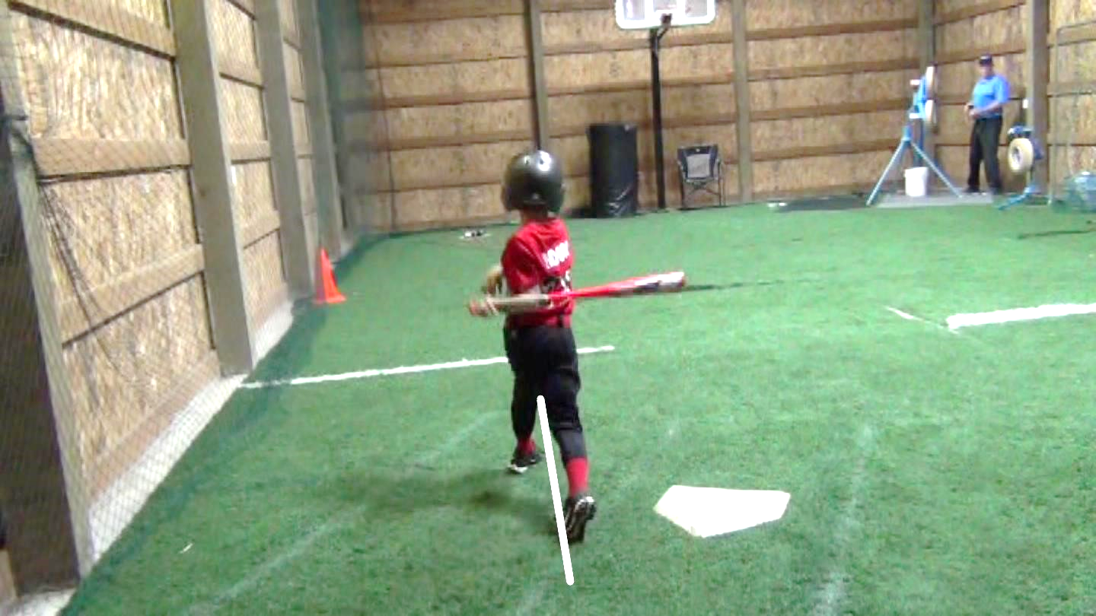

Excessive opening of the front foot reduces power and plate coverage.
Improving power and productivity, developing hitters deliberately practice increasing the rate of solid contact, especially for outside pitches, by utilizing techniques allowing the hitter to “stay on the ball.” Here are the lower body mechanics to emphasize:

- Maintain the front side shoulder, knee, and hip inward until toe touch (see Foundation XXIX: Front Side In).

- Land stride closed at thirty-degrees.

- Maintain closed front foot angle during front heel drive and through contact.

Experienced Hitters

The experienced hitter can experiment with front foot angle within the range of ten to forty-five degrees—fit front foot angle to the unique athlete and type of hitter. Contact and gap type hitters (see Stone XVI: Types of Hitters) may gravitate to a closed front foot angle, while home run hitters are generally slightly more open.

Front Foot Opening After Contact
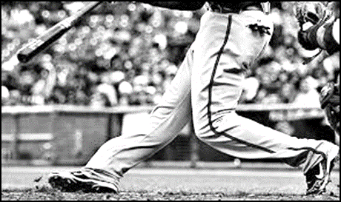

How much hitters’ front foot rotates open after contact varies. The location of the pitch dictates some of this variation. For example, inside pitches require core rotation to be early and aggressive, with likely more “peeling” open front foot after contact.

Variations are also a reaction to how much weight transfers to the front foot during the hitter’s approach. More weight forward keeps the front foot planted through follow-through; more weight rearward may result in the front toe spinning up and toward the pitcher after contact.

As long as the hitter remains balanced, the degree of front foot opening after contact is not a mechanic that needs coaching.

Drills

The Ultimate Hitting Training Guide:

- Tool XIV: Universal Leg Drills, Drill II – Stay on the Ball Drill.
- Tool XV: Experimental Leg Drills, Drill I – Front Foot Angle Experimentation Drill.

Pillar III
Rear Knee Drive

Universal

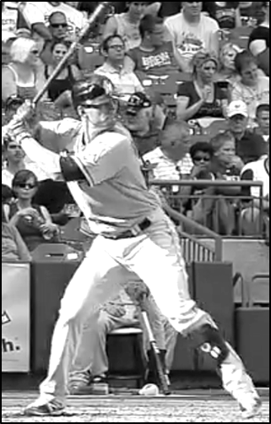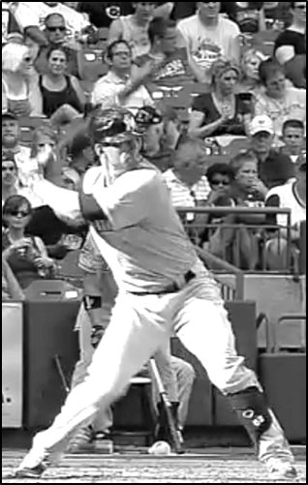
Toe Touch Inward (Pressing) Rear Knee Drive

Rear knee drive is essential for all hitters to master. Lower body mechanics create energy by pushing against the ground and then facilitating energy transformation up the kinetic links. Excellent lower body fundamentals distinguish the High-Level hitter.

Linear Momentum Translates to Angular Momentum

The hitter’s approach begins from a point where most weight has been gathered rearward. The flexed rear leg (see Foundation XX: Rear Leg Flexion) pushes against the ground initiating the approach. Most hitters arrive at front heel plant with weight evenly distributed between feet.

Rear knee drive now “presses” the torso into the firm front side (see Pillar V: Firm Front Side). This inward push of the rear knee assists 1) forward weight transfer and 2) front heel drive in firing core rotation. Then hips take over, pulling the back leg through, resulting in an un-weighting of the rear foot. These powerful ground force movements transfer (conserve) momentum and energy from the hitter’s gather and approach to the rotation of the hips (see Pillar VII: Core Rotation).

Inward Knee Drive Mechanics

Crucially, the rear knee stays closed, making an inside move toward the front knee. The back foot does not pivot as knee drive occurs (see Debate VIII: Squish the Bug?). The instep and big toe of the rear foot are the points from which the forward push occurs. The big rear toe anchors the swing to the ground during gather and approach, and through the initial stages of core rotation.

Drills

The Ultimate Hitting Training Guide:

- Tool XIV: Universal Leg Drills, Drill III – Rear Knee Drive Drill.

Pillar IV
Rear Knee Hinge

Universal

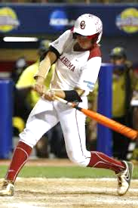
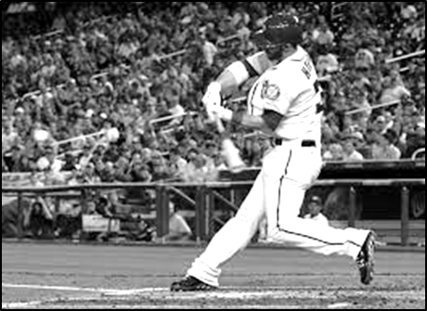
Hinged Rear Knee - Rear Foot on Toe Hinged Rear Knee - Rear Foot Off the Ground

The back leg generates power by pushing against the ground during gather, approach, and the initial portion of the rotational phase (see Pillar III: Rear Knee Drive). During rear knee hinge and the establishment of a firm front side (see Pillar V: Firm Front Side), the back leg finally “gives up,” transferring and conserving energy up the kinetic links to core rotation.

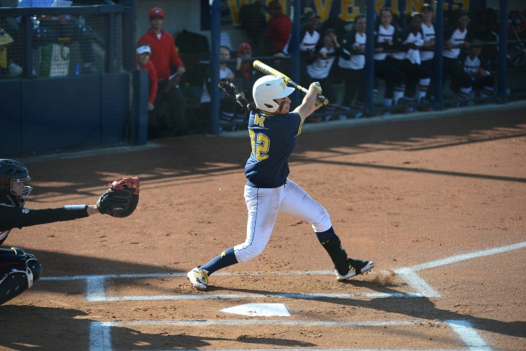
A common issue with developing hitters is that hips begin to rotate, but weight remains back with the rear heel on or close to the ground (image left). The rear foot is not un-weighted, and the back ankle and knee remain fixed after rear knee drive (instead of being pulled through). The constrained lower body puts a limit (due to flexibility) on shoulder rotation. The result is a reduced energy swing, especially in the outer part of the hitting area.

Benefits of Rear Knee Hinge
Hinging the rear knee allows the hitter to:

- Pass energy developed from the legs working against the ground to core rotation.

- Tilt rearward (see Pillar IX: Axis of Rotation).

- Not get too broad with the legs, especially after an aggressive stride, thereby inhibiting core rotation.

- Maintain balance (see Pillar VI: Balance).

- Keep head and shoulders level during stride and approach, increasing the ability to see the ball clearly and maintain a stable swing path.
Un-Weighting Rear Foot

As the forward momentum of the approach comes up against the firm front side, the dominant hitter allows their rear foot to become un-weighted.

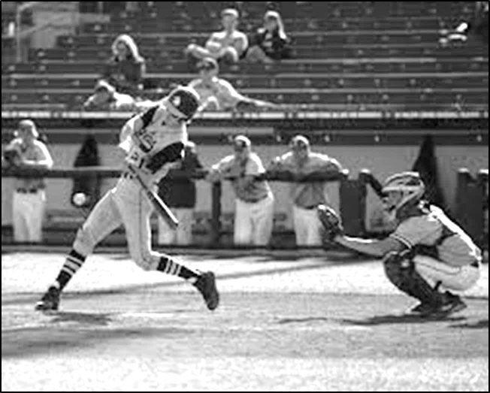
“You throw a ball; you transfer your weight to the leg closest to your target. You throw a punch, your weight transfers. You throw a Frisbee, your weight transfers. I decided to simply look at the position of our 50 hitters’ back feet at the point of contact to see whether their feet were exhibiting any signs of weight being put on them. Here are the results:”

Back Foot | Count
Bent | 2
Toe | 22
Drag | 12
Off | 14
(Farnsworth, Breaking Down the Swing: Best Hitters of 2012, 2013)

The hitter can “stay back” but still transfer weight to the front foot!

Core Rotation Hinges Rear Knee
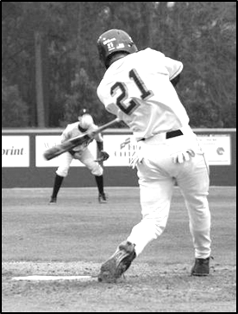
Successful hitters hit off their front leg, using the front leg as the lower portion of a rotational axis (see Stone XXV: Rotational Motion and Pillar IX: Axis of Rotation).

As the rear foot becomes un-weighted, the rear ankle is pulled over the top of the foot by the rotating core. Core rotation drags the back knee and ankle through as the hips open completely; the rear leg mustn't force the hinging of the back knee.

The rear knee is fully hinged when the rear shoelaces and back knee face the pitcher with little to no weight on the rear foot.

Turn of Rear Hip Hinges Rear Knee
Rear Knee Hinge Mechanics

Rear knee hinge is executed by:

- Rear knee drives the torso into a firm front side (see Pillar III: Rear Knee Drive), un-weighting the back foot and allowing core rotation to hinge the rear leg.

- Initially, the rear ankle stays back. The back foot does not pivot on its own.

- The rear knee hinges naturally, without forcing, as the hips turn.

- Use the rear hip turn to pull the back foot onto the toe (“show the shoelaces”).

- The rear knee hinges close to the front knee.

- At contact, the rear knee is slightly forward of the hitter’s head (images below) (see Pillar IX: Axis of Rotation and Pillar XV: Rotate Around a Centered and Steady Head).

Degree of Hinging

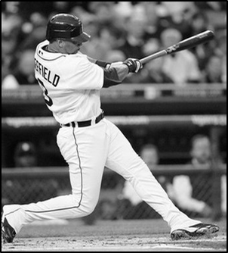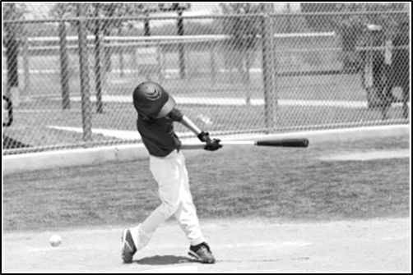
Ninety-degree Hinge Forty-five-degree Hinge (Nice Job!)

The degree of rear knee hinge is governed mainly by the distance between the feet and the angle of tilt in the hitter’s axis. Hitters who utilize an aggressive stride and have their axis tilted more rearward (left image) create a more defined “L” shape. A batter who uses a less aggressive stride or drags the rear foot forward at contact has a lower degree of hinging (right image).

Developing Hitters

It is challenging for developing hitters to hinge the rear knee. Moving and positioning each leg is an intricate motor pattern. The hitter trains their back leg to relax and be pulled through by the rear hip simultaneously as they straighten and block their front leg (see Pillar V: Firm Front Side).

Commonly, the youth hitter’s rear leg straightens to match the front leg. Correct any straightening of the back leg before contact because:

- The hitter tends to lunge forward.

- The hitter’s shoulders and head may rise as the rear leg straightens.

The hitter’s legs are typically bent and athletic in their stance and into hitting position. Depending on the aggressiveness of the stride, straightening both legs often causes the upper body to rise. It is crucial that the head and shoulders stay steady and swing path unaltered as core rotation occurs.

Aggressive Striders

Hitters with an aggressive stride and approach, where they dramatically flatten the “V” made by the legs, un-weight the rear foot, and allow the rear hip to drag the rear toe a few inches forward. Especially for aggressive striders, maintaining weight on the back foot inhibits core rotation and causes the head and shoulders to drop substantially.

Drills

The Ultimate Hitting Training Guide:

- Tool XIV: Universal Leg Drills, Drill VI – Un-Weight Rear Foot Drill.
- Tool XIV: Universal Leg Drills, Drill IV – Rear Knee Hinge Drill.

Debate VIII
Squish the Bug?

Next on the docket, Senators examine the validity of an “ancient” Roman edict, “Squish the Bug.” Squish the bug is a way of introducing core rotation (see Pillar VII: Core Rotation) to younger players. The hitter pivots on the ball of the rear foot. As they do so, they push the ball of the foot into the ground, thereby squashing the bug. This action has the effect of turning the hips.

Roman Senators separate into two different “parties” based on how they believe successful hitters implement core rotation:

Party 1 - Squish the Bug

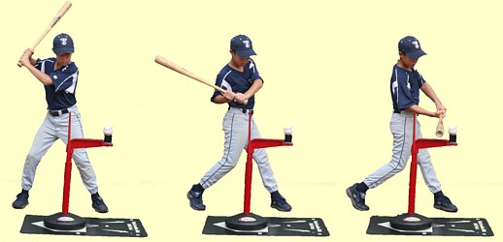
Squishing Bug

One cluster of Senators proclaims weight never transfers forward; instead, hitters swing with most of their weight remaining on the rear foot. Just like MLB Barry Bonds, hitters hit off their back foot, not their front foot. A coach of young Roman citizens is the first to speak:

“The weight transfer is from back to middle. The back foot remains in solid contact with the ground. The hitter must not let the bug escape before he squashes it!” (Anonymous, Hitting Forum, 2012)

Now a Major League Baseball Hitting coach:

“First the lower half. The back knee will start to press and turn inward once the swing is started. Many young hitters try to extend the back knee, which is wrong. "Squash the bug" is a good saying, because it makes the hitter use his back knee to transfer the power and weight to the hands. A hitter never wants to be out on his front foot. He wants to have his weight balanced throughout his swing.” (Major League Hitting Philosophy, n.d.)

Party 2 – Un-weight Rear Foot

A boisterous group of Senators asserts “squish the bug” causes hitters to:
- Hit with substantial weight on their rear foot.

For a hitter to forcefully engage their hips into the swing, weight must come off the rear foot. The forward transfer of bodyweight (during the approach phase) coming up against a firm front side enables un-weighting the back foot (see Pillar V: Firm Front Side). When this happens, core rotation (see Pillar VII: Core Rotation) can occur smoothly without resistance.

- Lose the energy built up during gather and approach.
The energy built up by the legs working against the ground must be transferred smoothly to the rotating hips. When squish the bug turns the rear ankle, which turns the back knee, which turns the hips, this breaks the chain of energy created by previous kinetic links (see Stone XXI: Kinetic Links). Just as the driver who “rides the brakes” while pushing the gas pedal, squish the bug acts as a “brake” to core rotation

Senate Ruling

Squish the Bug Easily Misperceived
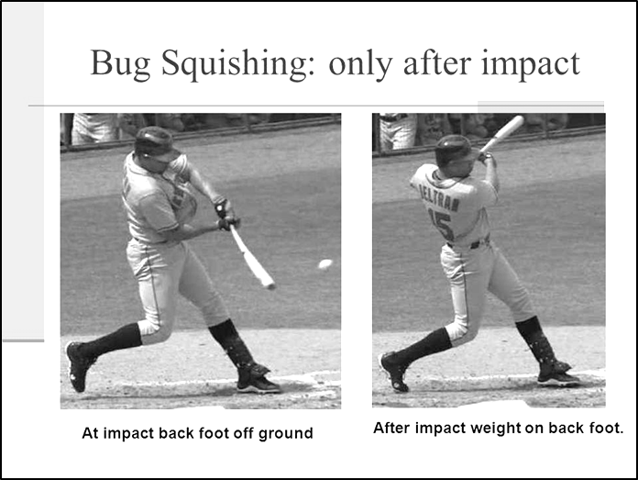
Whether the hitter turns to toe or pivots on the ball of the back foot can be challenging to identify when viewed at game speed. Body mass rebounds off the firm front side very quickly, bouncing the hitter into a squish the bug position during the follow-through. But with the advent of clear, slow motion video, great hitters can be seen transferring nearly all of their weight to the front leg during their approach. With few exceptions, the rear foot becomes un-weighted by contact.

Pure Rotational
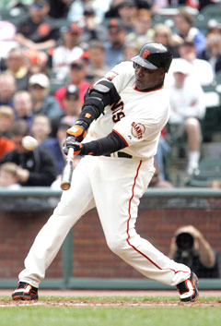
A small minority of High-Level hitters have a squish the bug position at contact. With experienced hitters, this is usually the result of a “pure” rotational strategy where there is little or no forward (linear) movement of the torso during approach. At least half of bodyweight remains on the rear foot at contact.

Yes, Barry Bonds hit off his back foot. He also used CHP and THT and BHT and Circular Extension techniques to generate tremendous bat speed (see Pillar XIII: Lead Shoulder Opening Strategies, Pillar XXVI: Rotational with Circular Hand Path, and Dome XVII: Outside Pitch with Circular Hand Path), thus compensating for the lack of linear translation of body weight into angular velocity. Barry’s hitting style was and still is unique in many ways.

Conclusion

Over 95% of High-Level hitters transfer their entire body weight to the front leg at the moment of impact.

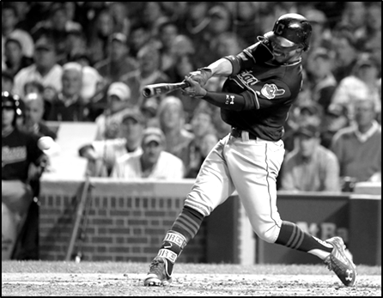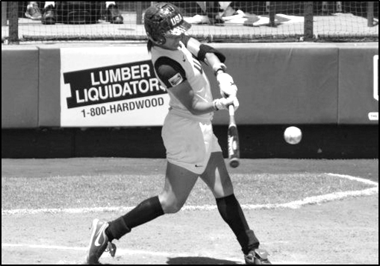
Un-weighted Rear Foot at Contact (Universal)

The hips leading rear ankle and shoulders followed by a pivot to toe is one of the defining techniques of the High-Level swing. It is notable, golfers, quarterbacks, pitchers, tennis players, and many other athletes also release or make contact with nearly all weight on the front foot.

Drills

The Ultimate Hitting Training Guide:

- Tool XIV: Universal Leg Drills, Drill IV – Rear Knee Hinge Drill.
- Tool XIV: Universal Leg Drills, Drill VI – Un-Weight Rear Foot Drill.

Pillar V
Firm Front Side

Universal

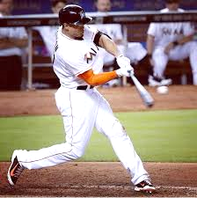
High-Level hitters Universally employ a firm front side to conserve and transfer the momentum created by the hitter’s gather and approach to the rotating torso.

Stated scientifically, blocking the front leg takes advantage of ground power, converting linear momentum into angular velocity (see Stone XX: Torque, Moment of Inertia, and Angular Velocity).

A firm front side is a critical kinetic link (see Stone XXI: Kinetic Links) for generating maximum potential bat speed.

Firm Front Side Mechanics
Here are the essential mechanics used to construct the Firm Front Side Pillar:

- Rear knee press.
Rear knee drive (see Pillar III: Rear Knee Drive) presses the torso into the firm front side to assist in firing core rotation. The front hip is kept stable, or driven rearward, by the firming front leg. These powerful ground force movements help open the hips.

- Blocking action halts forward movement and establishes an axis of rotation.
As the heel plants or just after, the front leg pushes against the ground halting forward momentum. This blocking action establishes an axis of rotation (see Stone XXV: Rotational Motion and Pillar IX: Axis of Rotation). Having a stable rotational axis is critical for delivering maximum power to the ball.

- “Blocked Not Locked.”

The front leg is almost straight, with muscles flexed (blocked). When force is applied, athletes avoid completely straightening and locking their knees.

Collapsed Front Side
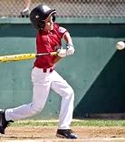
Soft Front Side

Hitters who consistently contact the ball with a bent front leg (collapsed front side) are reducing:
- Energy transfer.
When the front side collapses, angular momentum dissipates as hips continue to slide forward. The hitter does not conserve and transfer the energy generated during gather and approach to core rotation.

- Torque.

Typically, a collapsing knee results in the hitter’s torso and head moving forward towards or over their front foot. Lunging eliminates the hitter’s axis, dramatically diminishing torque and speed (see Stone XX: Torque, Moment of Inertia, and Angular Velocity).

Drills

The Ultimate Hitting Training Guide:

- Tool XIV: Universal Leg Drills, Drill V – Firm Front Side Drill.

Pillar VI
Balance

Universal

In this final Pillar of Chapter 5 Legs, the hitter constructs consistent balance while performing maximum effort swings.

Benefits of Good Balance

A hitter with stable balance is better able to:

- Swing harder.
- Swing a heavier bat.
- Transfer weight forward during their approach.
- Adjust to pitch locations.
- Control body for off-speed pitches.
- Keep their eyes steady and see the ball well.
- Get out of the batter’s box quicker.

Achieving Good Balance

Great hitters rarely lose balance. During the swing and follow-through, they do not step into or away from the plate to regain balance. Here are four prerequisites:

- Obtain an athletic hitting position (see Foundation XXXIII: Spine Angle).

- Maintain a steady head as the swing executes (see Pillar XV: Rotate Around a Centered and Steady Head). The hitter loses balance away from the plate if they rise into a more upright posture (pull head) as the swing executes.

- Allow the rear knee to hinge (see Pillar IV: Rear Knee Hinge).

Maintaining balance while leaning slightly sideways into the plate as the hitter turns (see Pillar VIII: Stable Spine Angle) is enabled by rear knee hinge. Losing balance into the plate is generally caused by the straightening of the back leg.

- Athletic width of feet (see Foundation XXIV: Adjust Stride and Approach).

When a hitter swings aggressively, from a too narrow or overly wide, non-athletic width of feet, staying balanced is challenging.

Drills

The Ultimate Hitting Training Guide:

- Tool XIV: Universal Leg Drills, Drill VII – Balance Drill.

Progress of Your Roman Pillars!

